USPS University Seminars
Classes begin February, 2008
Register on line at USPS.ORG, call (860) 402-3800 or email seomanchester@aol.com
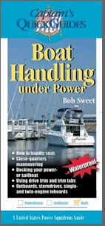
USPS University is here with new programs targeted to a range of boaters and types of boating. The hallmark of this concept is the Seminar Series. These short seminars are targeted to specific topics and needs with a two-hour format, and valuable take-away guides. Each seminar provides credits toward the soon to be released Boat Operator Certification program. Classes are open to the public!
Boat Handling under Power
Have you ever watched a captain dock his boat and wonder how he makes it look so easy? This seminar shows boaters how to depart and dock under a variety of conditions affected by weather, wind and currents. Trimming the boat while underway is also covered. The seminar materials include a waterproof USPS Captain's Quick Guide and Student Notes.

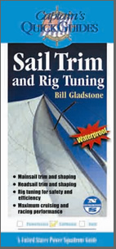
Sail Trim and Rig Tuning

This seminar shows in clear and simple terms how to use and adjust sails on your sailboat for optimum performance under a wide range of conditions. The seminar comes with a waterproof USPS Captain's Quick Guide written by North Sails and Student Notes.

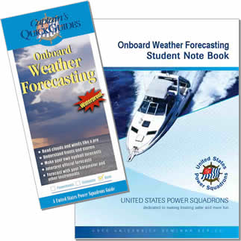
Onboard Weather Forecasting
Changing weather conditions can convert what was a delightful day on the water into a real challenge. Forecasting what weather you will encounter is one of the top priorities for safe boating. Should we go out? When should we come in? These are important questions, but some fundamental understanding of the weather can help you make these decisions. That’s what this seminar is all about.
While not a course in weather, this seminar explains how just using your own senses can help you determine what conditions you will encounter where you are. By all means, a forecast is important. It will tell you what weather systems are headed your way, but they are challenged to tell exactly where and when conditions will change. Add your own observations and you have an extra edge. Add a couple of instruments and you can verify your observations. The seminar explains weather systems, how to understand clouds and their changes, using changing wind direction, temperature, and pressure to hone in on emerging weather fronts. The seminar includes the McGraw-Hill Onboard Weather Forecasting waterproof Captain’s Quick Guide to take aboard your boat.

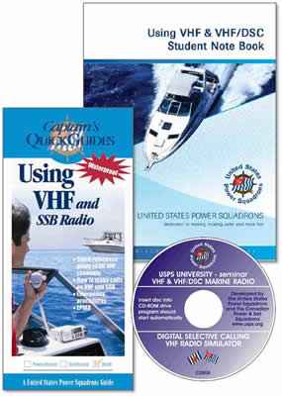
Using VHF & VHF/DSC Marine Radio
VHF radio is the mainstay of coastal communication and essential for emergency communications. Digital Selective Calling (DSC) is rapidly becoming a reality as more Coast Guard Rescue 21 System operations go live. DSC vastly simplifies and improves rescue and routine call signaling – making it easier to make a call while the system frees up Channel 16 for essential communications. However, you need to know how to use it. This seminar answers those needs and explains basic VHF operation. A CD is included with a DSC Simulator that allows you to practice on your computer at home. A handy waterproof McGraw-Hill Captain’s Quick Guide Using VHF is included with essential information that you should have aboard, which will explain to anyone on your crew how to use the radio.

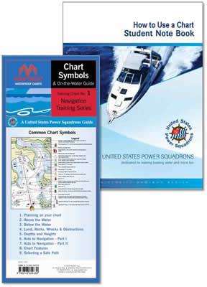
How to Use a Chart
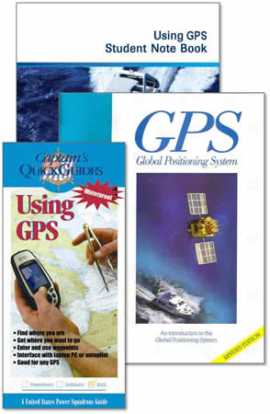
Charts provide information essential to your safety afloat. Even with GPS and electronic navigation, the chart is needed to tell you what is around you and between you and your intended destination. There is key information about visible landmarks and navigation aids to help you navigate your course. The chart also is your link with the GPS via its grid scale, compass rose, and distance scales. The NOAA Chart No. 1 is the quintessential reference to chart details, but is very difficult to understand. This seminar walks you through what you really need to know in an entertaining and interesting fashion, and provides you with a Maptech Waterproof flip-fold waterproof Chart Symbols and On-the-Water Guide to take along on the boat with you. This seminar walks you through the essentials of laying out a safe course, steps to measure a course with the USPS plotter, and even a quick guide to the rules of the road.

Using GPS
GPS has become a common tool for navigation. However using GPS on the water is distinctly different from a moving map display in your car. This seminar explains the principles of waypoint navigation which you will use. It then shows you how to relate the GPS to your charts which provide essential information about what is around you. The seminar also shows you how to operate your GPS – what the buttons do, what the screens show, and how to access the functions you need. A handheld GPS is used as the demonstration model, but all GPS receivers function similarly. By the time you have completed the seminar, you will be able to store waypoints into your GPS, activate them for navigation, and use GPS to keep you on a safe, pre-qualified course of your choosing.. You will get a copy of the USPS GPS Guide and a waterproof McGraw-Hill Captain’s Quick Guide Using GPS to take aboard to remind you of the steps, or to show another of your crew how to use your GPS.

